PRACTICAL : 5
Date: 12/08/2026
What is Internet ?
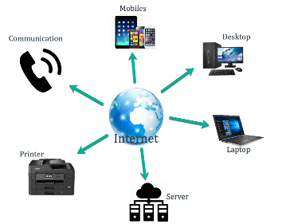
The internet is a massive, global network of smaller computer networks linked together. It lets billions of devices—like phones, computers, and servers—talk to each other and share data across the world using a shared set of rules called protocols.

How was Internet developed ?
The internet was created through a series of computer science breakthroughs starting in the 1960s, beginning with ARPANET funded by the US Department of Defense, moving to TCP/IP communication rules in 1983, and expanding with Tim Berners-Lee’s invention of the World Wide Web in 1989.
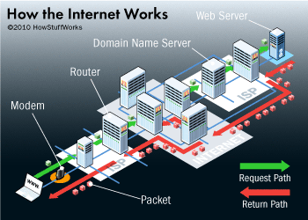
How does internet work ?
The internet is a giant, global network of connected computers and devices. It works by breaking data into small pieces called packets. These packets travel across physical cables and wireless signals, guided by routers to reach specific digital addresses in milliseconds .

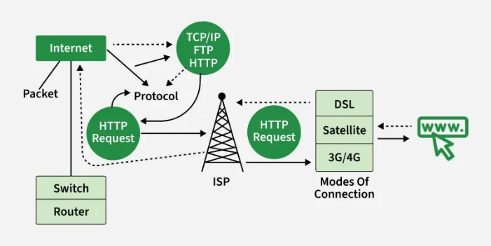

Define internet base service , communication , information , world wide web .
The Internet is a global network of connected computers. The World Wide Web (WWW) is a system of linked pages and media that runs on top of that network. Together, they provide the hardware and rules needed for worldwide communication, data sharing, and digital services.
The Internet vs. The World Wide Web
- The Internet: The physical network of wires, cables, servers, and routers.
- The Web (WWW): The collection of text, pictures, and video you view using a browser.
- Difference: The Internet is the road system; the Web is the collection of stores and signs built on those road .
Core Building Blocks of the Web
- URL: The unique address of a specific webpage.
- HTTP: The rule set used to send files between servers and browsers.
- HTML: The code that builds what you see on a screen.
Major Services Provided
- Communication: Email, video calls, and chat tools.
- Information Sharing: Search engines, digital libraries, and news sites.
- Web Services: Online banking, shopping stores, and video streaming

